

**LA GRANDEE INTERNATIONAL COLLEGE**

**Simalchaur, Pokhara, Nepal**

A Project Proposal/Report

on

**Attendify+**

**Submitted to**

La Grandee International College

Bachelor of Computer Application (BCA) Program

In partial fulfillment of the requirements for the degree of Program Name under

Pokhara University

**Submitted by**

|  |  |  |  |
| --- | --- | --- | --- |
| **Name:** | **Course** | **Semester** | **P.U. Registration Number** |
| Namrata Bastola | BCA | 6th | 2022-1-53-0129 |
| R.a.mohan Tiwari | BCA | 6th | 2022-1-53-0136 |
| Rikita Gharti | BCA | 6th | 2022-1-53-0138 |
| Subash Gurung | BCA | 6th | 2022-1-53-0147 |

**Date: 28 April 2024**

**Table of Content**

Table of figures iii

1. Introduction 1

2. Problem Statement 3

3. Objectives 4

4. Background Study 5

5. Methodology 7

6. Project gantt chart 9

7. Deliverables 10

# Table of figures

Fig 5. 1: Methodology 8

Fig 6. 1: Project Gantt Chart 9

# 1. Introduction

With the rapidly evolving education system today, precise and secure tracking of student attendance has become a basic necessity. Manual systems, such as paper registers or basic biometric devices, are often inadequate, prone to proxy attendance, plagued by data management issues, and burdened by administrative inefficiencies.

**Attendify+** is envisioned as an advanced, secure, and real-time attendance management system designed to overcome these limitations. Built specifically for use in schools and academic institutions, Attendify+ not only facilitates the core attendance-taking process but also enhances verification through integrated features such as QR code scanning, geolocation detection, device fingerprinting, and optional face capture technology. These smart processes ensure that attendance records are authentic, tamper-proof, and easy to manage.

Beyond regular classroom attendance, Attendify+ also supports event-based tracking through **entry and exit QR scanning** for workshops, seminars, and special sessions. This enables institutions to accurately monitor student participation, engagement duration, and interest levels in various activities, providing deeper insights into extracurricular involvement.

Additionally, Attendify+ introduces an independent study logging feature, allowing students to record self-study sessions and promoting a culture of academic responsibility and personal discipline. Administrators benefit from the system's powerful analytics tools, offering insights into attendance patterns, session engagement, and overall student participation trends over time.

Developed using PHP, MySQL, HTML, CSS, and Bootstrap, Attendify+ is highly scalable and adaptable to the evolving needs of institutions. Whether installed as a complete package on a local network or complemented with cloud-based analytics, the system ensures flexibility, enhanced security, and user-friendly operation, establishing a transparent, efficient, and technology-driven attendance management environment.

# 2. Problem Statement

With increasing modernization of educational institutions, traditional methods of taking attendance are proving to be less efficient. Paper-based traditional registers and simple biometric systems have several drawbacks:

1. Proxy Attendance: It is simple for students to fake attendance records by marking absent students as present, disrupting the integrity of information.

2.Manual Mistakes and Loss of Data: Semi-digital or paper-based systems are prone to manual mistakes, physical loss of documents, and an inability to maintain past records.

3.Ineffective Session Monitoring: Legacy systems do not monitor attendance for out-of-the-box sessions like workshops, seminars, and events effectively, nor do they capture engagement length.

4.Inadequate Real-Time Insights: Administrators have no real-time visibility into attendance patterns, thus slowing down decision-making and data-driven strategies.

To address these problems of utmost importance, Attendify+ presents a complete-scale, real-time attendance management system with cutting-edge technologies like QR code scanning, location verification, entry and exit tracking of events, and solid analytics for admins.

# 3. Objectives

1. Reliable Attendance Recording

To provide a reliable platform for electronic recording of student attendance, eliminating human errors and minimizing manual intervention.

2. Prevent Proxy Attendance

To contribute to the authenticity of attendance records through the use of QR code scanning and device verification procedures.

3. Event-Based Attendance Tracking

To facilitate entry and exit QR scanning for workshops, seminars, and special sessions to properly monitor participation and engagement time.

4.Real-Time Analytics Dashboard

To enable administrators to have real-time insights into attendance behaviors, session participation, and student engagement through dynamic dashboards and reporting interfaces.

5. Flexible Deployment Options

To design the system for local network deployment as well as optional cloud-based analytics for flexibility in accommodating institutional needs.

6. Secure and Scalable System Architecture

To build a secure, scalable PHP, MySQL, HTML, CSS, and Bootstrap platform that will scale with the future needs of an institution.

# 4. Background Study

With the quick speed of technical and digital communications advancements, educational institutions are in need of efficient, secure, and real-time attendance management techniques. Paper register, manual inputs, or plain biometric modules are no longer adequate to suit the growing demand for accuracy, security, and efficiency in managing attendance.

With the rise of digital platforms, numerous industries have changed, and education is one of them. Institutions nowadays comprehend the importance of adopting clever attendance systems that not only simplify the recordal process of student attendance but also enhance the integrity of attendance data by leveraging advanced verification technologies. QR code-based attendance, geolocation verification, device fingerprinting, and optional face capture are some of the functionalities that provide institutions with robust tools to minimize proxy attendance and maximize academic accountability.

In addition, there is a greater necessity to monitor student participation outside traditional classrooms — such as seminars, workshops, and independent study classes — to be able to penetrate further into the realms of student involvement and academic activity. Current systems are not designed with the agility and analysis necessary for such broad-based monitoring.

Attendify+ was developed to address these increasing demands. The technology leverages modern web technologies — PHP, MySQL, HTML, CSS, and Bootstrap — to provide a scalable, secure, and user-friendly attendance management system. Attendify+ aims not only to automate the simple attendance process but also integrate advanced verification methods and real-time analytics, giving schools a panoramic view of student participation.

In general, the background of Attendify+ originated from responding to evolving times within the education system by embracing an intelligent, secure, efficient, and effective digital attendance system that yields meaningful insights into the learning process. Our project aims to increase institutional effectiveness while supporting openness, responsibility, and accountable engagement culture among learners.

# 5. Methodology

Each stage of the Agile Scrum model is followed in our application on the basis of:

1. Product Backlog Creation:

Here we gather all system requirements and feature requests for Attendify+, such as initial loggings of attendees, QR check-ins, geolocation validation, event tracking, and analytics.

We prioritize the features in the backlog, select the most critical tasks for the first sprint (e.g., building the core attendance marking system), and set goals for the sprint cycle.

2. Sprint Execution and Daily Scrum:

The development team as a whole works on the selected features. Progress is inspected, problems solved, and tasks adjusted as needed through daily Scrum meetings.

3. Sprint Review:

At the conclusion of each sprint, we demonstrate completed features — e.g., QR attendance module or admin dashboard — to stakeholders and get confirmation and feedback.

4. Sprint Retrospective:

After reviewing the sprint, the team reviews the sprint process, identifies areas for improvement, and makes planning procedure adjustments for the next sprint so they can work more efficiently and effectively.

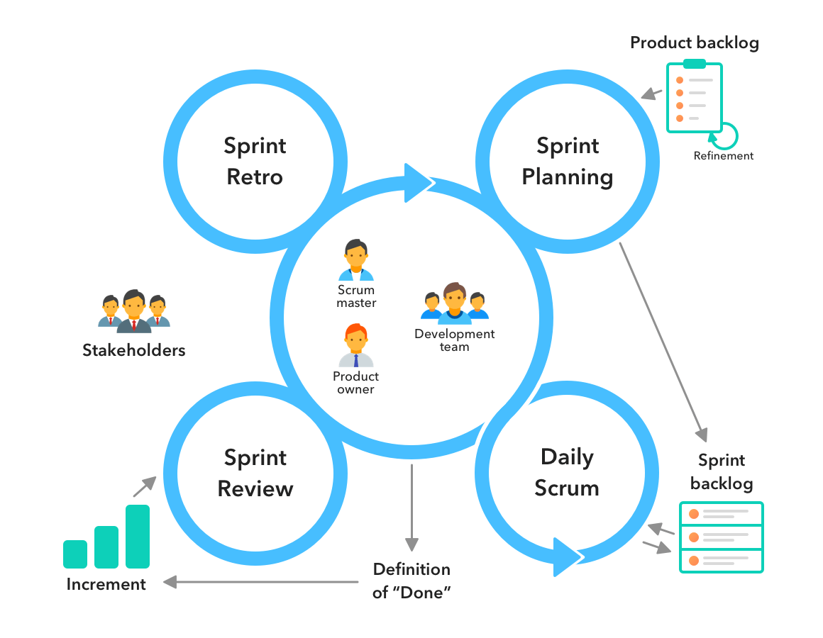

Fig 5. 1: Methodology

# Project gantt chart

Using a Gantt Chart in the development of the Attendify+ system enables effective project planning, task scheduling, and progress tracking. Each phase of the project — from requirement analysis to final deployment — is visually mapped with specific timelines, allowing the team to monitor deadlines and dependencies clearly.

The Gantt Chart approach facilitates a structured workflow by breaking down the entire system development into manageable tasks, ensuring that activities such as core attendance module creation, QR code integration, location verification, and analytics dashboard development are systematically prioritized and completed on time.

By regularly updating the Gantt Chart, the team can assess project status, identify potential delays early, and adjust plans accordingly to maintain smooth progression throughout the Agile Scrum development cycles.

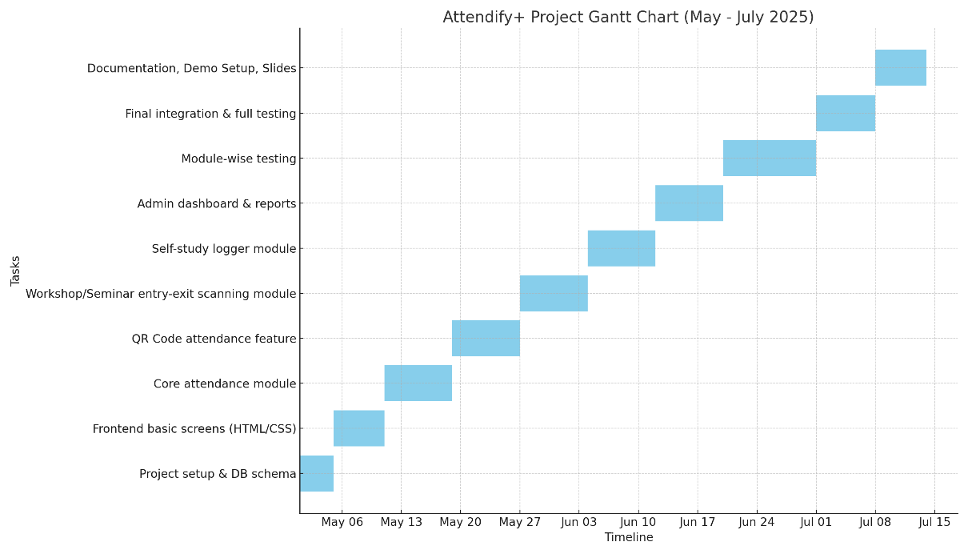

Fig 6. 1: Project Gantt Chart

# 7. Deliverables

Once developed, certain expectations are to be fulfilled to ensure Attendify+ works well and accomplishes the goal of administrators, faculty members, and students.

The primary deliverables of the project are presented below:

1. Attendance Management System Complete and Working:

A holistic web-based system for secure real-time recording of attendance by students via multiple verification options.

2. QR Code Attendance Feature:

Dynamic QR code scanning and generation for rapid and secure student check-in in workshops, seminars, and classes.

3. Entry and Exit Event Tracking System:

Advanced QR code scanning system for monitoring student entry and exit from workshops, seminars, and special sessions, recording engagement time.

4. Self-Study Logger Module:

Students' interface to capture independent study sessions, activities, and tasks to instill academic discipline outside classroom.

5. Real-Time Analytics Dashboard:

Solid dashboard for managers to follow attendance trends, engagement levels, event participation, and generate attendance reports.

6. Secure User Authentication and Role Management:

Secure login process with student, teacher, and manager separation to provide proper access control.

7. Detailed System Documentation:

Complete user manual and technical documentation, such as system architecture diagrams, installation guides, and maintenance guides.

S